Grating & Related Products



1


Forging partnershipsTM


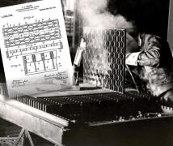

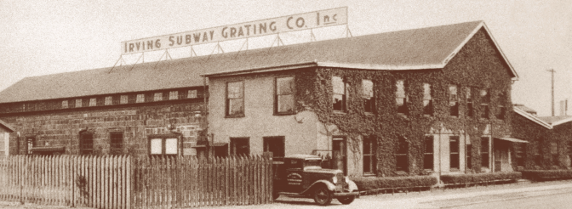
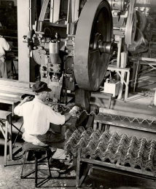
IKG is the world’s leading manufacturers of high quality steel and aluminum bar grating with manufacturing plants throughout North America.
Our skilled network of sales personnel and engineering staff is the most knowledgeable in the industry, providing consultative services and solutions to customers in a wide range of industries.
IKG carries on the pioneering spirit of its founders, bringing experience, quality, long-term value added solutions and time- tested reliability to its customers today.
Through consistent, competitive, and dependable cutomer care, Forging Partnerships ™ has become synonymous to IKG.

Call us at (800) 324-8417

Advantages and Applications

When and Why to Choose Grating:
Choose grating instead of solid flooring when you need:
• Open areas to allow passage of light, air and heat between flooring levels.
• Flooring on which liquids and / or debris cannot collect.
• Easy installation and fabrication.
• Adaptability to complex floor patterns and hard-to-fit areas.
• High strength–to–weight ratio.

Advantages:

Applications:

• Strength and low weight specified  • Light and air passage | • Ease of Installation  • Security  • Durability

• Industrial Flooring  • Trenches  • Maintenance Platforms  • Walkways  • Power Plants  • Refineries | • Chemical Plants  • Bridge Decks  • Warehouses  • Water and Waste Treatment Plants  • Steel Mills
All grating products are manufactured to NAAMM tolerances and specifications.
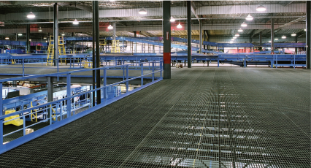


Forging partnershiSTM

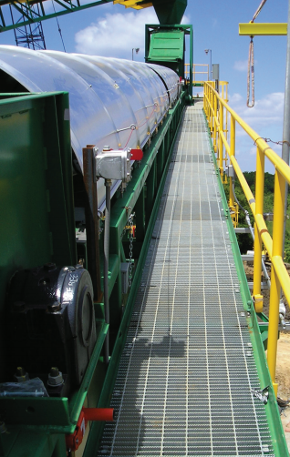
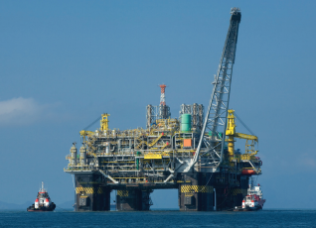

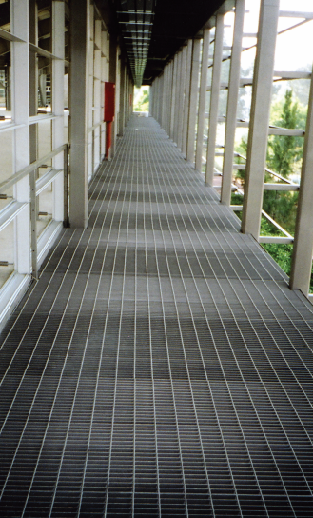
Weldforged® Steel Grating
Recommended for general applications.

Same as Type W/B but with closer cross bars spacing.

Close bearing bars.
Best for heavy public
traffic, where increased carrying capacity is
required.

Same as type W/D but with closer cross bar spacing.
4”
1- 3/16“
SPAN
2”
1- 3/16 “
SPAN

4 ”

15/16 “
SPAN
2”
15/16 “
SPAN


Forging partnershipsTM

Type

Standard | W/B
 | W/F
 | W/D
 | W/DF

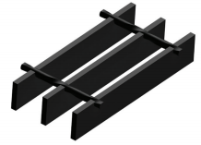

Weight lb./sf.
Bar  Size | Bearing Bar  Dimensions  (inches) | Grating Types
 |  | WB | WF | WD | WDF
2 | 3/4” x 3/16 “ | 5.8 | 6.7 | 7.2 | 8.1
3 | 1” X 1/8” | 5.2 | 6.1 | 6.4 | 7.3
4 | 1” x 3/16” | 7.5 | 8.4 | 9.3 | 10.2
5 | 1-1/4” x 1/8” | 6.3 | 7.2 | 7.9 | 8.8
6 | 1-1/4” x 3/16” | 9.1 | 10.0 | 11.3 | 12.2
7 | 1-1/2” x 1/8” | 7.4 | 8.3 | 9.3 | 10.2
8 | 1-1/2” x 3/16” | 10.8 | 11.7 | 13.5 | 14.4
9 | 1-3/4” x 3/16” | 12.5 | 13.4 | 15.6 | 16.5
10 | 2” x 3/16” | 14.1 | 15.0 | 17.7 | 18.6
11 | 2-1/4” x 3/16” | 15.8 | 16.7 | 19.8 | 20.7
12 | 2-1/2” x 3/16” | 17.4 | 18.3 | 21.9 | 22.8

Twisted square cross bar*

*A round cross bar is used for Stainless Steel
Rectangular bearing bar
Forge welded joints

Surfaces:
• Plain
• Serrated
• MEBAC®
Finishes:
• Mill
• Galvanized
• Painted
• GrateCoat®

Panel sizes:
• 3´ x 20´ 2´ x 20´
• 3´ x 24´ 2´ x 24´

Available in:
• Carbon Steel
• Stainless Steel (304L & 316L)

1/4” and 3/8” bearing bar thicknesses are also available. Please call for assistance.

LOAD TABLE FOR THE WELDFORGED® GRATING
This table is good for typeW/B and W/F only.


Forging partnershiSTM

*Recommended max. span (in.) for 1/4” deflection under uniform load of 100lb/sf.

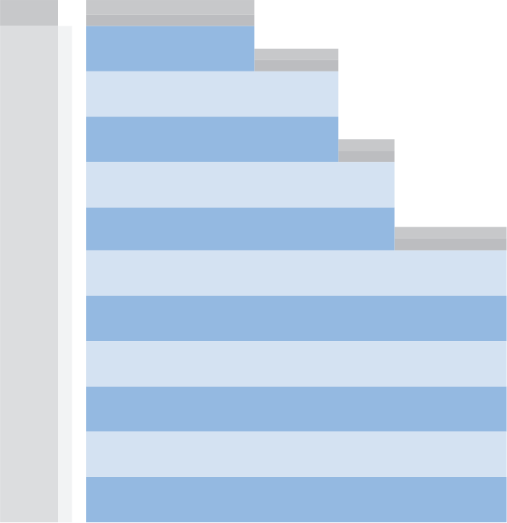  Size | Bearing  Bar (in) | Span in inches  Percentages of Open Area  Rectangular Types  Grating Type Bearing Bar Thickness  1/8” 3/16”  W/B 82.4% 77.1%  W/F 75.9% 70.7%  W/D 77.3% 70.4%  W/DF 70.9% 64.1%  237  0.372  592  0.298  658  0.134  987  0.107  196  0.451  538  0.36  121  0.730  423  0.584  140  0.629  455  0.504  1480  0.060  1480  0.048  483  0.182  846  0.146  292  0.302  658  0.241  947  0.093  1184  0.074  164  0.536  493  0.429  370  0.238  740  0.191  U  D  C  D  67  Span in inches  96 102  101 89 79 70  0.698 0.794 0.897 1.006  379 355 334 316  0.559 0.636 0.718 0.804  90  108  * 24 U 533 D 0.099 46 C 533 D 0.079 30 341 0.155 426 0.124 36 237 0.223 355 0.179 42 174 0.304 305 0.243 48 133 0.397 266 0.318 54 105 0.503 237 0.402 379 0.372 158 0.372 395 0.298 334 0.451 130 0.451 359 0.360 316 0.536 110 0.536 329 0.429 Span in inches 78 93 0.629 304 0.504 84 81 0.730 282 0.584 Span in inches 60 66 72 101 84 70 0.466 0.563 0.670 253 230 211 0.372 0.451 0.536 152 125 105 0.466 0.563 0.670  U 632 51 D 0.074 C 632 D 0.060 404 0.116 505 0.093 281 0.168 421 0.134 206 0.228 361 0.182 158 0.298 316 0.238 125 0.377 281 0.302  U 947 57 D 0.074 C 947 D 0.060 606 0.116 758 0.093 421 0.168 632 0.134 309 0.228 541 0.182 237 0.298 474 0.238 187 0.377 421 0.302  U 987 61 D 0.06 C 987 D 0.048 632 0.093 789 0.074 439 0.134 658 0.107 322 0.182 564 0.146 247 0.238 493 0.191 195 0.302 439 0.241  U 1421 909 632 464 355 281 227 188 158 135 116  D 0.050 0.078 0.112 0.152 0.199 0.251 0.310 0.376 0.447 0.524 0.608  70  C 1421 1137 947 812 711 632 568 517 474 437 406  D 0.040 0.062 0.089 0.112 0.159 0.201 0.248 0.300 0.358 0.420 0.487
2 | 3/4” x 3/16”
3 | 1” x 1/8”
4 | 1” x 3/16”
5 | 1-1/4” x 1/8”
6 | 1-1/4” x 3/16”
7 | 1-1/2” x 1/8”
8 | 1-1/2” x 3/16” | 77 | U  D  C  D | 2132  0.050  2132  0.040 | 1364  0.078  1705  0.062 | 947  0.112  1421  0.089 | 696  0.152  1218  0.122 | 533  0.199  1066  0.159 | 421  0.251  947  0.201 | 341  0.310  853  0.248 | 282  0.376  775  0.300 | 237  0.447  711  0.358 | 202  0.524  656  0.420 | 174  0.608  609  0.487 | 152  0.698  568  0.559 | 133  0.794  533  0.636 | 118  0.897  502  0.718 | 105  1.006  474  0.804
9 | 1-3/4”x 3/16” | 87 | U  D  C  D | 2901  0.043  2901  0.034 | 1857  0.067  2321  0.053 | 1289  0.096  1934  0.077 | 947  0.130  1658  0.104 | 725  0.170  1451  0.136 | 573  0.215  1289  0.172 | 464  0.266  1161  0.213 | 384  0.322  1055  0.257 | 322  0.383  967  0.306 | 275  0.450  893  0.360 | 237  0.521  829  0.417 | 206  0.599  774  0.479 | 181  0.681  725  0.545 | 161  0.769  683  0.615 | 143  0.862  645  0.689
10 | 2” x 3/16” | 96 | U  D  C  D | 3789  0.037  3789  0.03 | 2425  0.058  3032  0.047 | 1684  0.084  2526  0.067 | 1237  0.114  2165  0.091 | 947  0.149  1895  0.119 | 749  0.189  1684  0.151 | 606  0.233  1516  0.186 | 501  0.282  1378  0.225 | 421  0.335  1263  0.268 | 359  0.393  1166  0.315 | 309  0.456  1083  0.365 | 269  0.524  1011  0.419 | 237  0.596  947  0.477 | 210  0.673  892  0.538 | 187  0.754  842  0.603
11 | 2-1/4” x 3/16” | 105 | U  D  C  D | 4796  0.033  4796  0.026 | 3069  0.052  3837  0.041 | 2132  0.074  3197  0.06 | 1566  0.101  2741  0.081 | 1199  0.132  2398  0.106 | 947  0.168  2132  0.134 | 767  0.207  1918  0.166 | 634  0.250  1744  0.200 | 533  0.298  1599  0.238 | 454  0.350  1476  0.280 | 392  0.406  1370  0.324 | 341  0.466  1279  0.372 | 300  0.530  1199  0.424 | 266  0.598  1128  0.478 | 237  0.670  1066  0.536
12 | 2-1/2” x 3/16” | 113 | U  D  C  D | 5921  0.03  5921  0.024 | 3789  0.047  4737  0.037 | 2632  0.067  3947  0.054 | 1933  0.091  3383  0.073 | 1480  0.119  2961  0.095 | 1170  0.151  2632  0.121 | 947  0.186  2368  0.149 | 783  0.225  2153  0.180 | 658  0.268  1974  0.215 | 561  0.315  1822  0.252 | 483  0.365  1692  0.292 | 421  0.419  1579  0.335 | 370  0.4777  1480  0.381 | 328  0.538  1393  0.431 | 292  0.603  1316  0.483
U = Uniform load lb./sf. C = Concentrated load lb./ft. of grating width, at mid-span. D = Deflection in inches.
For spacings other than 1-3/16” centers, multiply the conversion factor times the U and C values shown in the table, the D (deflection) remains as shown.

Type | W/D | W/DF
Factor | 1 | .27

CONVERSION DATA: SERRATED GRATING
Grating Size | 3/4” x 3/16” | 1” x 1/8” | 1” x 3/16” | 1-1/4” x 1/8” | 1-1/4” x 3/16” | 1-1/2” x 1/8” | 1-1/2” x 3/16” | 1- 3/4” x 3/16” | 2” x 3/16” | 2-1/4” x 3/16” | 2-1/2” x 3/16”
Multiply U & C by: | .70 | .77 | .77 | .81 | .81 | .84 | .84 | .85 | .88 | .89 | .90
Multiply deflection by: | 1.20 | 1.14 | 1.14 | 1.11 | 1.11 | 1.09 | 1.09 | 1.08 | 1.07 | 1.06 | 1.05
Note: All deflections are theoretical and are based on standard engineering practices. They are provided for design selection only and should not be considered as absolute.


Swage Locked Aluminum Grating
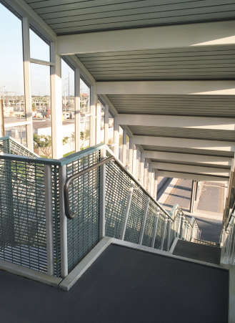
Forging partnershipsTM

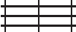
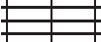Type
Recommended for general applications.

Same as IB and BS but with closer cross bar spacing.

The close bearing bars provide a greater loading capacity than IB / BS without increasing the depth of the section.
Same as ID and DS
but with closer cross bar spacing.
Our closest spaced swage lock grating.
Satisfies maximum
clear opening required by ADA.
With closer cross bars and bearing bars. For conditions requiring
greatly reduced net
openings. Satisfies
maximum clear opening required by ADA.

4 ”

1- 3/16“
SPAN

2”

1- 3/16“
SPAN
— 4 ”
15/16“
SPAN
2”
15/16“
SPAN
4”
11/16 “
SPAN
2”
11/16 “
SPAN

Standard Space | IB  BS
IF
FS
Close Space | ID  DS
IDF
DFS
Very Close Space | ICM4  SCM4
ICMF4
SCMF4

Rectangular Bar Grating
(BS, FS, DS, DFS, SCM4, SCMF4)
BS swaged rectangular bar grating provides all the strength of alumi- num pressure locked grating at a slightly lower cost. The cross bars are swaged to lock the bearing bars in place, giving you high strength and rigidity in a light weight, virtually maintenance free aluminum grating.

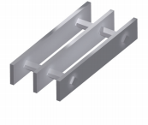

I-Bar Grating
(IB, IF, ID, IDF, ICM4, ICMF4)
IB swaged aluminum I-Bar grating is the lightest weight, lowest cost aluminum grating. Its high strength, slip resistant striated bearing bars and low cost, I-Bar grating is an excellent choice when economy is a major factor.
Surfaces:
• Plain
• Serrated*
• MEBAC®
Finishes:
• Mill
• Anodized
• Duranodic
*Only rectangular bar is serrated. I-Bar type is striated on top surface.

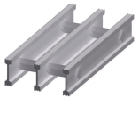
Panel sizes:
• 3´ x 20´ 2´ x 20´
• 3´ x 24´ 2´ x 24´

Weights lb./sf.
Size | Bearing  Bar Depth  (inches) | Swage Locked  “I Bar”Type |  |  |  |  |  | Bearing Bar  Dimensions  (inches) | Swage Locked  “Rectangular Bar”Type
 |  | IB | IF | ID | IDF | ICM4 | ICMF4 |  | BS | FS | DS | DFS | SCM4 | SCMF4
3 | - | - | - | - | - | - | - | 1” x 1/8” | 1.9 | 2.2 | 2.3 | 2.6 | 3.0 | 3.3
4 | 1” | 1.9 | 2.1 | 2.3 | 2.5 | 3.2 | 3.5 | 1” x 3/16” | 2.6 | 2.9 | 3.3 | 3.5 | 4.3 | 4.6
5 | - | - | - | - | - | - | - | 1-1/4” x 1/8” | 2.3 | 2.6 | 2.8 | 3.1 | 3.6 | 4.0
6 | 1-1/4” | 2.3 | 2.5 | 2.8 | 2.9 | 3.8 | 4.2 | 1-1/4” x 3/16” | 3.2 | 3.5 | 4.0 | 4.3 | 5.3 | 5.6
7 | - | - | - | - | - | - | - | 1-1/2” x 1/8” | 2.8 | 3.2 | 3.4 | 3.8 | 4.3 | 4.6
8 | 1-1/2” | 2.6 | 2.8 | 3.2 | 3.4 | 4.5 | 4.8 | 1-1/2” x 3/16” | 3.9 | 4.3 | 4.8 | 5.2 | 6.3 | 6.6
9 | 1-3/4” | 3.0 | 3.3 | 3.7 | 3.9 | 5.1 | 5.4 | 1-3/4” x 3/16” | 4.5 | 4.9 | 5.6 | 5.9 | 7.2 | 7.6
10 | 2” | 3.4 | 3.7 | 4.2 | 4.4 | 5.8 | 6.1 | 2” x 3/16” | 5.1 | 5.5 | 6.3 | 6.7 | 8.2 | 8.6
11 | 2-1/4” | 3.8 | 4.0 | 4.6 | 4.9 | 6.4 | 6.8 | 2-1/4” x 3/16” | 5.7 | 6.1 | 7.0 | 7.4 | 9.2 | 9.5
12 | 2-1/2” | 4.0 | 4.2 | 4.9 | 5.1 | 7.1 | 7.4 | 2-1/2” x 3/16” | 6.3 | 6.7 | 7.8 | 8.1 | 10.2 | 10.5

LOAD TABLE FOR SWAGE LOCKED GRATING
This table is good for type IB, BS, IF and FS only.


Forging partnershiSTM

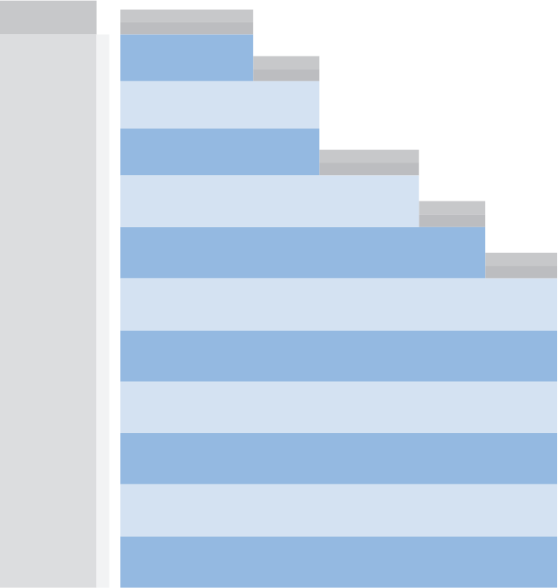  Size | * Maximum span for 1/4” deflection under uniform load of 100lb/sf.  30  35  42  24  247  0.461  493  0.369  237  0.384  474  0.307  110  0.037  329  0.829  105  0.864  316  0.691  439  0.259  658  0.207  421  0.216  632  0.173  158  0.720  395  0.576  152  0.600  379  0.480  322  0.353  564  0.282  309  0.294  541  0.235  195  0.583  439  0.467  187  0.486  421  0.389  81  1.411  282  1.129  77  1.176  271  0.941  93  1.217  304  0.973  90  1.014  291  0.811  130  0.871  359  0.697  125  0.726  344  0.581  987  0.115  987  0.092  947  0.096  947  0.077  632  0.180  789  0.144  606  0.150  758  0.120  U  D  1-1/4” x 3/16”  or 1-1/4” I Bar  52  Span in inches  90 96  67 59  1.350 1.536  253 237  1.080 1.229  C  D  U  D  1-1/2” x 1/8”  53  C  D  Bearing Bar Size  Span in inches  * 35 U D C D 355 0.191 355 0.153 227 0.299 284 0.239 158 0.432 237 0.345 116 0.588 203 Span in inches 0.470 48 54 137 105 83 0.441 0.576 0.729 241 211 187 0.353 0.461 0.583 206 158 125 0.441 0.576 0.729 361 316 281 Span in inches 0.353 0.461 0.583 60 66 72 215 164 130 105 87 73 0.353 0.461 0.583 0.72 0.871 0.037 376 329 292 263 239 219 Span in inches 0.282 0.369 0.467 0.576 0.697 0.829 78 84  3/4” x 3/16”  1” x 1/8” 39 U D C D 421 0.144 421 0.115 269 0.225 337 0.180 187 0.324 281 0.259  1” x 3/16” or 1” I Bar 44 U D C D 632 0.144 632 0.115 404 0.225 505 0.180 281 0.324 421 0.259  1-1/4” x 1/8” 47 U D C D 658 0.115 658 0.092 421 0.180 526 0.144 292 0.259 439 0.207
2
3
4
5
6
7
8 | 1-1/2” x 3/16” or  1-1/2” I Bar | 59 | U  D  C  D | 1421  0.096  1421  0.077 | 909  0.150  1137  0.120 | 632  0.216  947  0.173 | 464  0.294  812  0.235 | 355  0.384  711  0.307 | 281  0.486  632  0.389 | 227  0.600  568  0.480 | 188  0.726  517  0.581 | 158  0.864  474  0.691 | 135  1.014  437  0.811 | 116  1.176  406  0.941 | 101  1.35  379  1.080 | 89  1.536  355  1.229
9 | 1-3/4” x 3/16”  or 1-3/4” I Bar | 66 | U  D  C  D | 1934  0.082  1934  0.066 | 1238  0.129  1547  0.103 | 860  0.185  1289  0.148 | 632  0.252  1105  0.202 | 484  0.329  967  0.263 | 382  0.417  860  0.333 | 309  0.514  774  0.411 | 256  0.622  703  0.498 | 215  0.741  645  0.592 | 183  0.869  595  0.695 | 158  1.008  553  0.806 | 138  1.157  516  0.926 | 121  1.317  484  1.053
10 | 2” x 3/16”  or 2” I Bar | 73 | U  D  C  D | 2526  0.072  2526  0.058 | 1617  0.113  2021  0.090 | 1123  0.162  1684  0.130 | 825  0.221  144  0.176 | 632  0.288  1263  0.230 | 499  0.365  1123  0.292 | 404  0.450  1011  0.360 | 334  0.545  919  0.436 | 281  0.648  842  0.518 | 239  0.761  777  0.608 | 206  0.882  722  0.706 | 180  1.013  674  0.810 | 158  1.152  632  0.922
11 | 2-1/4” x 3/16”  or 2-1/4” I Bar | 80 | U  D  C  D | 3197  0.064  3197  0.051 | 2046  0.100  2558  0.080 | 1421  0.144  2132  0.115 | 1044  0.196  1827  0.157 | 799  0.256  1599  0.205 | 632  0.324  1421  0.259 | 512  0.400  1279  0.320 | 423  0.484  1163  0.387 | 335  0.576  1066  0.461 | 303  0.676  984  0.541 | 261  0.784  914  0.627 | 277  0.900  853  0.720 | 200  1.024  799  0.819
12 | 2-1/2” x 3/16”  or 2-1/2” I BAR | 87 | U  D  C  D | 3947  0.058  3947  0.046 | 2526  0.090  3158  0.072 | 1754  0.130  2632  0.104 | 1289  0.176  2256  0.141 | 987  0.23  1974  0.184 | 780  0.292  1754  0.233 | 632  0.360  1579  0.288 | 522  0.436  1435  0.348 | 439  0.518  1316  0.415 | 374  0.608  1215  0.487 | 322  0.706  1128  0.564 | 281  0.810  1053  0.648 | 247  0.922  987  0.737
U = Uniform load lb./sf. C = Concentrated load lb./ft. of grating widht, at mid-span. D = Deflection in inches.

ALUMINUM CONVERSION FACTORS
For spacings other than 1- 3/16” centers, multiply the conversion factor times the U and C values shown in the table, the D (deflection) remains as shown.
Type | ID / DS | IDF / DFS | ICM4 / SCM4 | ICMF4 / SCMF4
Factor | 1.27 | 1.27 | 1.73 | 1.73
Note: The carrying capacity of a piece of grating subjected to a concentrated load over only a portion of its width is determined by the stiffness of both the bearing bars and the cross bars, and therefore differs with the type of grating used. To determine the carrying capacity of gratings subject to such loadings, the IKG engineering department should be consulted.



Aluminum Grating


Forging partnershipsTM

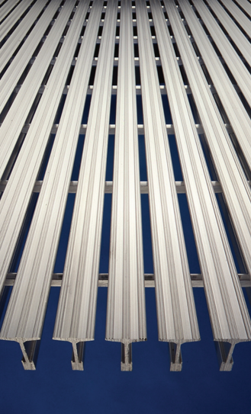
Frames to fit. We offer aluminum frames for concrete embedment that are made specifically for Safe T Grid® installation. Frames can be supplied with rubber cushion for total noise elimination and also with the same finish specified for the grating.
Comfortable. For both walking and standing. The broad top flange walking surface feels much like solid flooring underfoot.
Will not catch high heels. Openings of Type TB-940 are less that 1/4” wide, narrower than most slender high heels, yet sufficient to allow the free passage of air and water.
Rigid, rattle-free construction. Strong, tight swaging of cross bars locks bearing bars solidly in place with a positive lock that prevents the main bearing bars from racking or “venetian blinding ”. This result will last for years without loosening even under heavy traffic. Wide top flange of bearing bars gives added lateral rigidity.
Invisible fastening system. Special clips can be supplied with the grating that lock into the bottom flange of the bearing bars. Clips can be tightened from above with a screw driver or an Allen wrench, and can just as easily be released for removing the grating to clean the collection pit.

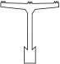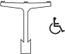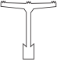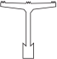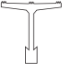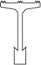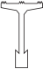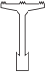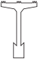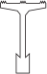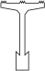
Aluminum Grating
—.935 ——— .940
T
Depth (Size)
1-7/8”

Size | Depth | Wt./sf. | Open Area
4 | 1” | 2.1 | 49.9%
6 | 1-1/4” | 2.8 | 49.9%
8 | 1-1/2” | 3.0 | 49.9%
10 | 2” | 3.4 | 49.9%
.626
Type TB -626

H——1

Size | Depth | Wt./sf. | Open Area
4 | 1” | 2.7 | 47.2%
6 | 1-1/4” | 3.3 | 47.2%
8 | 1-1/2” | 3.6 | 47.2%
10 | 2” | 4.1 | 47.2%
.940
T
Depth (Size)
1-3/16 ”

Size | Depth | Wt./sf. | Open Area
4 | 1” | 3.0 | 20.8%
6 | 1-1/4” | 4.2 | 20.8%
8 | 1-1/2” | 4.4 | 20.8%
10 | 2” | 5.0 | 20.8%
—.311
T
Depth (Size)
15/16 ”

Size | Depth | Wt./sf. | Open Area
4 | 1” | 3.4 | 33.2%
6 | 1-1/4” | 4.1 | 33.2%
8 | 1-1/2” | 4.4 | 33.2%
10 | 2” | 5.1 | 33.2%

Type TD -626
Type TB -940
Type TP -940
3/16 ”
.626
Depth (Size)
.2475
.5615
-
Panel sizes:
Surfaces:
• 3´ x 20´ 2´ x 20´
• 3´ x 24´ 2´ x 24´
• Standard striated top
• MEBAC®
Finishes:
• Mill
• Anodized
• Duranodic

LOAD TABLE FOR SAFE T GRID® GRATING


Forging partnershiSTM

* Maximum span for 1/4” deflection under uniform load of 100lb/sf.

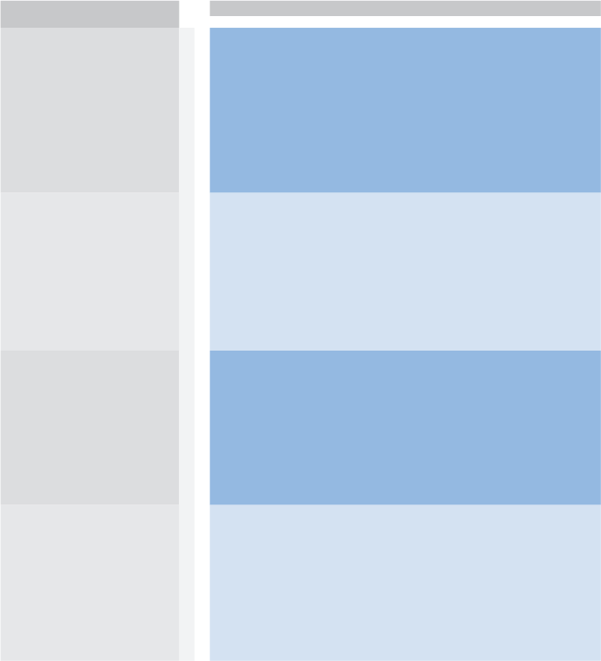  Size  No. | Depth | Type | Top  Flange  Width | S/FT | I/FT | *  46 | U  D  C  D | SPAN
 |  |  |  |  |  |  |  | 1’-0 | 1’-6 | 2’-0 | 2’-6 | 3’-0 | 3’-6 | 4’-0 | 4’-6 | 5’-0 | 5’-6 | 6’-0 | 6’-6 | 7’-0
4 | 1” | TP-940-4 | .940 | .332 | .192 |  |  | 2662  0.031  1331  0.024 | 1183  0.070  887  0.056 | 666  0.124  666  0.099 | 426  0.195  532  0.155 | 296  0.280  444  0.224 | 217  0.381  380  0.305 | 166  0.498  333  0.399 | 131  0.629  296  0.505 | 106  0.776  266  0.623 | 88  0.943  242  0.754 | 74  1.123  222  0.899 | 63  1.317  205  1.055 | 54  1.519  190  1.221
4 | 1” | TB-626-4 | .626 | .495 | .262 | 50 | U  D  C  D | 3961  0.033  1981  0.027 | 1761  0.076  1320  0.061 | 990  0.135  990  0.108 | 634  0.212  792  0.169 | 440  0.305  660  0.244 | 323  0.415  566  0.332 | 248  0.543  495  0.434 | 196  0.688  440  0.549 | 158  0.845  396  0.678 | 131  1.026  360  0.820 | 110  1.220  330  0.976 | 94  1.436  305  1.147 | 81  1.665  283  1.330
4 | 1” | TB-940-4 | .940 | .525 | .303 | 51 | U  D  C  D | 4204  0.031  2102  0.024 | 1868  0.070  1401  0.056 | 1051  0.124  1051  0.099 | 673  0.195  841  0.156 | 467  0.280  701  0.224 | 343  0.382  601  0.305 | 263  0.499  525  0.398 | 208  0.633  467  0.505 | 168  0.779  420  0.623 | 139  0.944  382  0.754 | 117  1.125  350  0.897 | 99  1.311  323  1.053 | 86  1.532  300  1.221
4 | 1” | TD-626-4 | .626 | .627 | .332 | 53 | U  D  C  D | 5018  0.033  2509  0.027 | 2230  0.076  1673  0.061 | 1254  0.135  1254  0.108 | 803  0.212  1004  0.169 | 558  0.305  836  0.244 | 410  0.415  717  0.332 | 314  0.543  627  0.434 | 248  0.687  558  0.550 | 201  0.849  502  0.678 | 166  1.026  456  0.820 | 139  1.217  418  0.976 | 119  1.436  386  1.146 | 102  1.655  358  1.328
6 | 1-1/4” | TP-940-6 | .940 | .550 | .409 | 55 | U  D  C  D | 4403  0.024  2202  0.019 | 1957  0.054  1468  0.43 | 1101  0.096  1101  0.077 | 705  0.151  881  0.120 | 489  0.217  734  0.174 | 359  0.295  629  0.237 | 275  0.386  550  0.309 | 217  0.488  489  0.391 | 176  0.604  440  0.483 | 146  0.733  400  0.584 | 122  0.868  367  0.696 | 104  1.019  339  0.818 | 90  1.187  315  0.949
6 | 1-1/4” | TB-626-6 | .626 | .757 | .505 | 58 | U  D  C  D | 6063  0.026  3032  0.021 | 2695  0.060  2021  0.048 | 1516  0.108  1516  0.086 | 970  0.168  1213  0.135 | 674  0.243  1011  0.194 | 495  0.330  866  0.264 | 379  0.432  758  0.345 | 299  0.545  674  0.437 | 243  0.676  606  0.539 | 200  0.814  551  0.653 | 168  0.969  505  0.777 | 144  1.144  466  0.911 | 124  1.325  433  1.058
6 | 1-1/4” | TB-940-6 | .940 | .869 | .646 | 62 | U  D  C  D | 6952  0.024  3476  0.019 | 3090  0.054  2317  0.043 | 1738  0.096  1738  0.077 | 1112  0.151  1390  0.120 | 772  0.217  1159  0.174 | 568  0.296  993  0.236 | 435  0.387  869  0.309 | 343  0.489  772  0.391 | 278  0.604  695  0.483 | 230  0.732  632  0.585 | 193  0.870  579  0.696 | 165  1.024  535  0.817 | 142  1.186  497  0.948
6 | 1-1/4” | TD-626-6 | .626 | .960 | .640 | 62 | U  D  C  D | 7680  0.027  3840  0.021 | 3413  0.060  2560  0.048 | 1920  0.108  1920  0.086 | 1229  0.168  1536  0.135 | 853  0.242  1280  0.194 | 627  0.330  1097  0.264 | 480  0.432  960  0.345 | 379  0.546  853  0.437 | 307  0.674  768  0.54 | 254  0.817  698  0.653 | 213  0.970  640  0.777 | 182  1.142  591  0.912 | 157  1.325  549  1.059
8 | 1-1/2” | TP-940-8 | .940 | .742 | .652 | 62 | U  D  C  D | 5939  0.020  2970  0.016 | 2640  0.046  1980  0.036 | 1485  0.081  1485  0.065 | 950  0.127  1188  0.102 | 660  0.184  990  0.147 | 485  0.250  848  0.200 | 371  0.327  742  0.261 | 293  0.414  660  0.331 | 238  0.512  594  0.409 | 196  0.618  540  0.495 | 165  0.737  495  0.589 | 141  0.867  457  0.692 | 121  1.001  424  0.802
8 | 1-1/2” | TB-626-8 | .626 | 1.010 | .798 | 65 | U  D  C  D | 8084  0.022  4042  0.018 | 3593  0.051  2695  0.041 | 2021  0.091  2021  0.072 | 1293  0.142  1617  0.113 | 898  0.205  1347  0.164 | 660  0.279  1155  0.223 | 505  0.364  1011  0.291 | 399  0.461  898  0.369 | 323  0.568  808  0.455 | 267  0.688  735  0.551 | 225  0.821  674  0.656 | 191  0.960  622  0.770 | 165  1.116  577  0.892
8 | 1-1/2” | TB-940-8 | .940 | 1.172 | 1.030 | 70 | U  D  C  D | 9378  0.020  4689  0.016 | 4168  0.046  3126  0.036 | 2344  0.081  2344  0.065 | 1500  0.127  1876  0.102 | 1042  0.184  1563  0.147 | 766  0.250  1340  0.200 | 586  0.327  1172  0.261 | 463  0.414  1042  0.331 | 375  0.511  938  0.409 | 310  0.619  853  0.495 | 260  0.735  781  0.589 | 222  0.865  721  0.691 | 191  1.001  670  0.802
8 | 1-1/2” | TD-626-8 | .626 | 1.280 | 1.011 | 69 | U  D  C  D | 10240  0.022  5120  0.018 | 4551  0.051  3413  0.041 | 2560  0.091  2560  0.072 | 1638  0.142  2048  0.113 | 1138  0.205  1707  0.164 | 836  0.279  1463  0.223 | 640  0.364  1280  0.291 | 506  0.461  1138  0.369 | 410  0.570  1024  0.445 | 339  0.690  931  0.511 | 284  0.818  853  0.655 | 242  0.961  788  0.770 | 209  1.116  731  0.892
10 | 2” | TP-940-10 | .940 | 1.177 | 1.350 | 75 | U  D  C  D | 9421  0.015  4710  0.012 | 4187  0.035  3140  0.028 | 2355  0.062  2355  0.050 | 1507  0.098  1884  0.078 | 1047  0.141  1570  0.113 | 769  0.192  1346  0.153 | 589  0.251  1178  0.200 | 465  0.317  1047  0.254 | 377  0.392  942  0.313 | 311  0.474  856  0.379 | 262  0.565  785  0.452 | 223  0.663  725  0.530 | 192  0.768  673  0.615
10 | 2” | TB-626-10 | .626 | 1.586 | 1.647 | 78 | U  D  C  D | 12692  0.017  6346  0.013 | 5641  0.039  4231  0.031 | 3173  0.069  3173  0.055 | 2031  0.108  2538  0.086 | 1410  0.156  2115  0.124 | 1036  0.212  1813  0.169 | 793  0.277  1587  0.221 | 627  0.351  1410  0.280 | 508  0.433  1269  0.346 | 420  0.524  1154  0.419 | 353  0.624  1058  0.499 | 300  0.731  976  0.585 | 259  0.849  907  0.679
10 | 2” | TB-940-10 | .940 | 1.859 | 2.132 | 84 | U  D  C  D | 14875  0.015  7438  0.012 | 6611  0.035  4958  0.028 | 3719  0.062  3719  0.050 | 2380  0.098  2975  0.078 | 1653  0.141  2479  0.113 | 1214  0.192  2125  0.153 | 930  0.251  1859  0.200 | 735  0.318  1653  0.254 | 595  0.392  1488  0.314 | 492  0.475  1352  0.379 | 413  0.564  1240  0.452 | 352  0.663  1144  0.530 | 304  0.770  1063  0.615
10 | 2” | TD-626-10 | .626 | 2.009 | 2.086 | 83 | U  D  C  D | 16077  0.017  8038  0.013 | 7145  0.039  5359  0.031 | 4019  0.069  4019  0.055 | 2572  0.108  3215  0.086 | 1786  0.156  2679  0.124 | 1312  0.212  2297  0.169 | 1005  0.277  2010  0.221 | 794  0.351  1786  0.280 | 643  0.433  1608  0.346 | 531  0.523  1462  0.419 | 447  0.624  1340  0.499 | 381  0.733  1237  0.586 | 328  0.849  1148  0.679
U = Uniform load lb./sf. C = Concentrated load, lb./ft. of grating width, at mid-span. D = Deflection in inches.
Theoretical values based on f = 12,000 PSI, E = 10,000,000 psi, gross section of bearing bar.
Note: All deflections are theoretical and are based on standard engineering practices. They are provided for design selection only and should not be considered as absolute.

Pressure Locked Grating

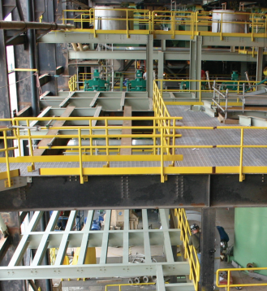
1- 3/16“
1- 3/16“
Type

B

F

D

DF

4 ”
SPAN

2”
SPAN


t 4 ” s
15/16“

SPAN

- 2”
15/16“  SPAN


Forging partnershipsTM
Recommended for general applications.

Closer cross bars. Best for heavy public traffic, or where smaller openings are required.

Same as type B but closer bearing bars for conditions where more steel area is required.

With closer cross bar and bearing bars. For conditions requiring greatly reduced net opening.

Pressure Locked Grating
Pressure locked grating incorporates tight-fitting, slotted bearing bars and cross bars, locked together. The permanent locking of the bars is accomplished by slotting the bearing bars with a wider “dovetail” shape at the bottom of the slot.
The bearing bar slot is usually 1/2 the depth of the cross bar. The cross bars are slotted to a depth slightly less than half the bar depth. When the bars are press together under hydraulic pressure, the cross bar material is forced into the “dovetail” shape of the bearing bar notch, forming a strong, rigid unit.

Weights lb./sf.
Bar  Size | Bearing Bar  Dimensions  (inches) | STEEL |  |  |  | ALUMINUM
 |  | B | D | F | DF | B | D | F | DF
1 | 3/4” x 1/8” | 4.4 | 4.8 | 4.6 | 5.5 | 1.6 | 1.7 | 1.7 | 2.0
2 | 3/4” x 3/16” | 5.7 | 7.0 | 6.4 | 7.7 | 2.0 | 2.5 | 2.2 | 2.7
3 | 1” x 1/8” | 5.2 | 6.4 | 6.0 | 7.2 | 1.9 | 2.3 | 2.2 | 2.6
4 | h | 7.5 | 9.3 | 8.3 | 10.1 | 2.6 | 3.3 | 2.9 | 3.5
5 | 1-1/4” x 1/8” | 6.3 | 7.9 | 7.1 | 8.7 | 2.3 | 2.8 | 2.6 | 3.1
6 | 1-1/4” x 3/16” | 9.1 | 11.3 | 9.9 | 12.2 | 3.2 | 4.0 | 3.5 | 4.3
7 | 1-1/2” x 1/8” | 7.6 | 9.5 | 8.7 | 10.6 | 2.8 | 3.4 | 3.2 | 3.8
8 | 1-1/2” x 3/16” | 11.0 | 13.7 | 12.1 | 14.8 | 3.9 | 4.8 | 4.3 | 5.2
9 | 1-3/4” x 3/16” | 12.7 | 15.8 | 13.8 | 16.9 | 4.5 | 5.6 | 4.9 | 5.9
10 | 2” x 3/16” | 14.3 | 17.9 | 15.4 | 19.0 | 5.1 | 6.3 | 5.5 | 6.7
11 | 2-1/4” x 3/16” | 16.0 | 20.0 | 17.1 | 21.1 | 5.7 | 7.0 | 6.1 | 7.4
12 | 2-1/2” x 3/16” | 17.7 | 22.1 | 18.8 | 23.2 | 6.3 | 7.8 | 6.7 | 8.1

Installation note:
Pressure locked grating should be installed with the “flush” side up. On 3/4 deep pressure locked grating where the cross bars and bearing bars are the same depth. IKG will mark the grating showing the top side for installation.
Top side

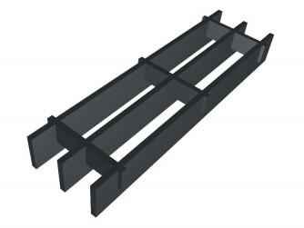
Flush cross bar

Surfaces:  • Plain  • Serrated  • MEBAC®  Finishes:  • Mill  • Galvanized  • Painted | Panel sizes:  • 3´ x 12´  • 2´ x 12´  Available in:  • Carbon Steel  • Stainless Steel (304L & 316L)  • Aluminum

Pressure Locked Close Mesh


Forging partnershiSTM

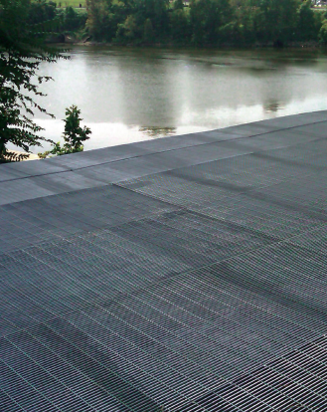
High heel proof 1/4” Clear opening.
Pressure locked grating is available with these close bar spacing to accommodate requirements for pedestrian comfort and safety as well as many other architectural needs for special grating for a particular job.

Weights lb./sf.
Bar  Size | Bearing Bar  Dimensions  (inches) | STEEL |  |  |  |  | ALUMINUM
 |  | CM-1 | CM-2 | CM-3 | CM-4 | CM-5 | CM-1 | CM-2 | CM-3 | CM-4 | CM-5
1 | 3/4” X 1/8” | - | 8.6 | 6.9 | - | 5.5 | - | 3.1 | 2.4 | - | -
2 | 3/4” X 3/16” | 13.7 | 13.3 | - | 9.0 | 7.8 | 4.7 | 4.1 | - | 3.1 | 2.7
3 | 1” X 1/8” | - | 11.5 | 9.0 | - | 7.1 | - | 4.2 | 3.1 | - | -
4 | 1” X 3/16” | 18.1 | 16.5 | - | 11.9 | 10.2 | 6.2 | 5.5 | - | 4.1 | 3.5
5 | 1-1/4” X 1/8” | - | 14.2 | 11.2 | - | 8.9 | - | 5.2 | 3.9 | - | -
6 | 1-1/4” X 3/16” | 22.6 | 20.7 | - | 14.8 | 12.7 | 7.8 | 6.9 | - | 5.1 | 4.4
7 | 1-1/2” X 1/8” | - | 17.2 | 13.5 | - | 10.8 | - | 6.3 | 4.7 | - | -
8 | 1-1/2” X 3/16” | 27.2 | 25 | - | 17.8 | 15.3 | 9.4 | 8.3 | - | 6.2 | 5.3
9 | 1-3/4” X 3/16” | 31.6 | 29.4 | - | 20.8 | 17.8 | 10.9 | 9.6 | - | 7.2 | 6.1
10 | 2” X 3/16” | 36.2 | 33.2 | - | 23.8 | 20.5 | 12.5 | 11.0 | - | 8.2 | 7.1
11 | 2-1/4” X 3/16” | 40.1 | 37.3 | - | 26.5 | 22.7 | 14 | 12.4 | - | 9.1 | 7.8
12 | 2-1/2” X 3/16” | - | 41.4 | - | 29.5 | 25.0 | - | 14.8 | - | 10.0 | 8.6

Type

CM1

CM2

CM3

CM4

CM5

7/16“:  1/2“  5/8 “ | 4”  SPAN  4”  SPAN  4”  SPAN

4”

11/16 “:
SPAN

4”

13/16 “
SPAN
Our closest spaced grating available. Excellent for
pedestrian use and areas
where high visibility is a
concern. Satisfies maximum 1/2” clear opening as
required by ADA.

Same as CM 1 only with a slightly increased opening. Satisfies maximum 1/2”
clear opening as required by ADA.
As with the other close
mesh types, this style
resists all small objects from falling through. Satisfies
maximum 1/2”clear opening as required by ADA.
Provides larger open area
for use where more ventila- tion is required beneath the grating. Satisfies, maximum 1/2” clear opening as
required by ADA.
Recommended for general applications.

Visit our website for loading information.
ADA Compliance:
If gratings are located in walking surfaces, then they shall have spaces no greater than ½ inch wide in one direction. If gratings have elongated openings, then they shall be placed so that the long dimension is perpendicular to the dominant direction of travel.

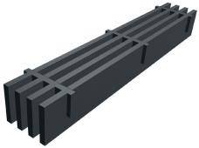
Flush cross bar

Surfaces:  • Plain  • Serrated  • MEBAC®  Finishes:  • Mill  • Galvanized  • Painted  • GrateCoat® | Panel sizes:  • 3´ x 12´  • 2´ x 12´  Available in:  • Carbon Steel  • Stainless Steel (304L & 316L)  • Aluminum

Treads

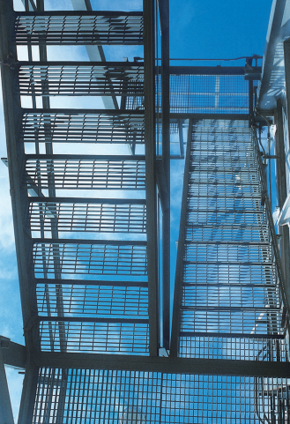
Nosing Types

1-1/4”
Checkered Plate
Steel Treads
only.
Integral MEBAC®
Angle Nosing

1-1/4” Cast
Aluminum Abrasive
Steel and Aluminum
Treads
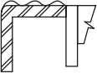
1-1/4” Corrugated Aluminum Extruded
Aluminum Tread only.


Forging partnershipsTM
IKG recommends the treads for stairs where maximum safety is required.

Grating Type Available:  • Weldforged®  • Swage Locked  • Pressure Locked  • Riveted  Surfaces:  • Plain  • Serrated  • MEBAC® | Finishes:  • Mill  • Galvanized  • Painted  • GrateCoat®  Material Available:  • Carbon Steel  • Stainless Steel (304L & 316L)  • Aluminum

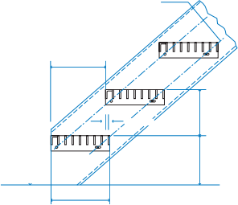
ha “ o holes in stringer

RUN

RISE
1/2 ” min.

RISE
Top of platform or finished floor

tread
WIDTH
Note: Tread width should always be greater than tread run by 1/2 in. (12mm) minimum.
Carrier Plate

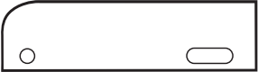
B
C

+
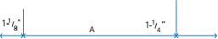
(See page 12) Finished Depth

Dimension B  • Steel Treads  1-3/4” up to including 1-1/4 ” deep treads. 2-1/4 ” for others | Dimension B  • Aluminum treads through 1-3/4” bearing bar depth will be 2-1/4”
7/16” Ø hole & slot, for 3/8 ” Ø bolt

Note: Bolts for mounting to stringers not supplied.

Treads

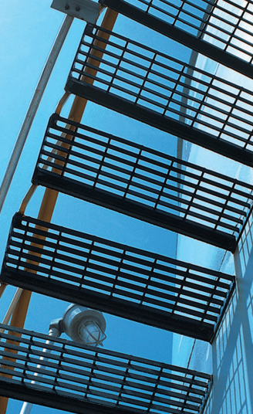

Table of Standard Tread Depths for:
Pressure Locked | Swage Locked | Riveted | *(Dimension A)  Hole Centers
Welded
B; W/B | IB | Type K (3/16 B.B.)
6-3/16“ | 6-1/4“ | 6-11/16“ | 2-1/2“
7-3/8“ | 7-7/16“ | 8“ | 4-1/2“
8-9/16“ | 8-5/8“ | 9-5/16“ | 4-1/2“
9-3/4“ | 9-13/16“ | 10-5/8“ | 7“
10-15/16“ | 11“ | 11-15/16“ | 7“
12-1/8“ | 12-3/16“ | 13-1/4“ | 7“

DIMENSION B in TREAD with carrier plate detail in. (mm)
Grating Depth | *Dimension B
3/4“ to 1/4“  1-1/2“and up | 1-3/4“  2-1/4“
Aluminum is usually 2-1/4 | ” (57) regardless of depth
*See Page 11


Forging partnershiSTM
Recommended Bearing Bar Sizes
*Maximum tread length based on 300 lb (133 kN) concentrated load on front
5 in. (127 mm) of tread at center of tread length and deflection limitation of L/240 of length. For maximum length under other loadings, consult the manufacturer.


SteelTreads
Bearing Bar  Size in. (mm)  3/4” x 3/16” | MaximumTread Length*
 | @ 1-3/16” (30) o.c. |  | @ 15/16” (24) o.c.
 | Plain  2´- 4” | Serrated  - | Plain  2´- 8” | Serrated  -
1” x 3/16” | 3´- 5” | 2´- 10” | 4´- 0” | 3´- 4”
1-1/4” x 3/16” | 4´- 8” | 4´- 2” | 5´- 1” | 4´- 6”
1-1/2” x 3/16” | 5´- 6” | 5´- 3” | 5´- 6” | 5´- 6”


Aluminum Treads (Rectangular Bars)
Bearing Bar Size  in. (mm)  1” x 3/16” | MaximumTread Length*
 | @ 1-3/16” (30) o.c. |  | @ 15/16” (24) o.c.
 | Plain  2´- 4” | Serrated  - | Plain  2´- 6” | Serrated  -
1-1/4” x 3/16” | 2´- 10” | 2´- 7” | 3´- 1” | 2´- 9”
1-1/2” x 3/16” | 3´- 6” | 3´- 2” | 3´- 10” | 3´- 6”
1-3/4” x 3/16” | 4´- 3” | 3´- 10” | 4´- 8” | 4´- 3”


Aluminum Treads I Bars
Bearing  Bar Size  in. (mm)  1” I | MaximumTread Length*
 | @ 1-3/16” (30)o.c.  2´- 4” | @ 15/16” (24)o.c.  2´- 6”
1-1/4” I | 2´- 10” | 3´- 1”
1-1/2” I | 3´- 6” | 3´- 10”
1-3/4” I | 4´- 3” | 4´- 8”

Safe T Grid® Treads Recommended Spans
Size | General Pu blic  Use | Commercial / Industrial
1”TP - 940 | 2´- 2 | 2´- 2
1”TB - 626 | 2´- 4 | 2´- 7
1”TB - 940 | 2´- 5 | 2´- 9
1”TD - 626 | 2´- 6 | 2´- 11
1-1/4”TP - 940 | 2´- 11 | 3´- 3
1-1/4”TB - 626 | 2´- 11 | 3´- 5
1-1/4”TB - 940 | 3´- 3 | 3´- 9
1-1/4”TD - 626 | 3´- 3 | 3´- 9
1-1/2”TP - 940 | 3´- 6 | 4´- 1
1-1/2”TB - 626 | 3´- 7 | 4´- 2
1-1/2”TB - 940 | 4´- 0 | 4´- 7
1-1/2”TD - 626 | 3´- 11 | 4´- 7
2”TP - 940 | 4´- 10 | 5´- 7
2”TB - 626 | 4´- 11 | 5´- 8
2”TB - 940 | 5´- 4 | 6´- 2
2”TD - 626 | 5´- 4 | 6´- 1
1. Recommended span for general uses for Safe T Grid® is developed by using a concentrated load of 300 pound with a 33% impact at midspan supported by:
Nosing plus 3 “T” bars forTP spacing
Nosing plus 4 “T” bars forTB spacing
Nosing plus 5 “T” bars for TD spacing
with a deflection not to exceed L/240 or .250 inches.
2. Recommended span for commercial / industrial uses is developed by using the same loading criteria as for general public but with a deflection not to exceed L/180 or .375 inches.

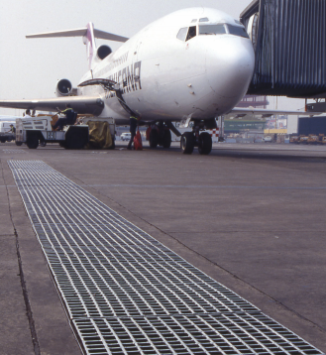



Heavy Duty Grating

Type
HWB
HWD
HWC
HWP
HWL

4”
1- 3/ “
16
SPAN
—— 4”
15/16 “
SPAN
4”
1- 3/8 “
SPAN
4 ”
1- 7/8“
4 ” 2- 3/8 “


Forging partnershipsTM

Bearing bars 1-3/16“ c/c Cross Bars 4” c/c
Bearing bars 15/16“ c/c Cross Bars 4” c/c
Bearing bars 1-3/8 “ c/c Cross Bars 4” c/c
Bearing bars 1-7/8 “ c/c Cross Bars 4” c/c
Bearing bars 2-3/8“ c/c Cross Bars 4” c/c
For Drains, Trenches and Scuppers.
Product designation
Design criteria
Style:
Basis of Design for Heavy Duty Grating
EC: Welded construction with rectangular cross bar welded at each joint.
HW: Welded construction with round cross bars welded at each joint.
AASHTO (American Association Society of State Highway Transportation Officials) Loadings for H-10, H-15, H-20
Bar SizeThickness:
Bar Size Designation:
A = 1/4” B = 5/16” C = 3/8”
Size # 10 = 2”
Size # 12 = 2-1/2”
Size # 14 = 3”
Size # 16 = 3-1/2”
Size # 18 = 4”

Wheel Load | H-10 | 10,400 Ibs. | (10”X10” print)
 | H-15 | 15,600 Ibs. | (15”X15” print)
 | H-20 | 20,800 Ibs. | (20”X20” print)
• Impact Factor, 30%
• Method of Load Distribution:
Each wheel distributed over a width of 10” (H-10); 15”
(H-15); 20” (H-20) plus 2 times the distance center-to- center of the bearing bars over a length on each bar equal to 10” for H-10, 15” for H-15 and 20” for H-20.
EXAMPLE: A product that has a main bar of 3-1/2” X 1/4” with the main bars spaced 1-3/8” o.c. is designated: HWC16A
• Maximum allowable stress in accordance with AASHTO specifi- cations for highway bridges, 1984 edition.
• Simple span.
All Heavy Duty Grating subject to rolling loads will be load banded, regardless of span.

Size of  Bearing Bar  2” X 1/4” | Type /  Style /  Size  C10A | Weights lb./sf. |  | Type /  Style /  Size  P10A | Weights lb./sf. |  | Type /  Style /  Size  L10A | Weights lb./sf.
 |  | EC  16.46 | HW  16.42 |  | EC  13.12 | HW  13.02 |  | EC  10.62 | HW  10.47
2” X 3/8” | C10C | 24.32 | 24.95 | P10C | 19.34 | 19.85 | L10C | 15.61 | 16.03
2-1/2” X 1/4” | C12A | 20.68 | 20.25 | P12A | 16.51 | 16.00 | L12A | 13.38 | 12.81
2-1/2” X 3/8” | C12C | 30.52 | 30.69 | P12C | 24.31 | 24.32 | L12C | 19.64 | 19.53
3” X 1/4” | C14A | 24.86 | 24.08 | P14A | 18.97 | 18.19 | L14A | 15.56 | 14.78
3” X 3/8” | C14C | 36.9 | 36.36 | P14C | 28.08 | 27.54 | L14C | 22.98 | 22.44
3-1/2” X 1/4” | C16A | 28.73 | 27.95 | P16A | 21.85 | 21.07 | L16A | 17.86 | 17.08
3-1/2” X 3/8” | C16C | 42.55 | 42.01 | P16C | 32.28 | 31.74 | L16C | 26.34 | 25.8
4” X 1/4” | C18A | 34.44 | 31.19 | P18A | 26.59 | 23.88 | L18A | 22.04 | 19.33
4” X 3/8” | C18C | 49.58 | 47.754 | P18C | 37.84 | 36.01 | L18C | 31.04 | 29.22
Please call for vehicular traffic table, panel sizes and spacing for increased lateral stability due to turning traffic and traffic traveling perpendicular to span.

Railroad Grating

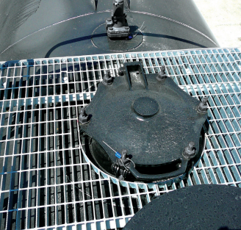

AAR  Group # | Size of  Bearing Bar | IKG  Symbol | Weight  Per Sq. Ft. | Unsupported  Span not to excced
1 | 1” x 1/8” | WRR3BC | 3.18 | 4 ' 0”
2 | 1-1/2“ x 3/16” | WRR8 | 8.33 | 7 ' 0”
3 | 2” x 3/16” | WRR10 | 10.55 | 10 ' 0”

Group # 1 WRR3BC  1.583” c/c | Group # 2 & 3 WRR8  WRR10  1.643” c/c | No. Bars
1-11/16” | 1-13/16” | 2
3-9/32” | 3-15/32” | 3
4-7/8” | 5 -1/8” | 4
6-15/32” | 6 -3/4” | 5
8-1/32” | 8 -13/32” | 6
9-5/8” | 10 -1/16” | 7
11-7/32” | 11-11/16” | 8
1' 0-25/32” | 1' 1- 3/16” | 9
1' 2- 3/8” | 1' 2- 31/32” | 10
1' 3-31/32” | 1' 4-5/8” | 11
1' 5-17/32” | 1' 6 -1/4” | 12
1' 7-1/8” | 1' 7-7/8” | 13
1' 8-23/32” | 1' 9-17/32” | 14
1' 10-9/32” | 1' 11- 3/16” | 15
1' 11-7/8” | 2' 0 -13/16” | 16
2' 1-7/16” | 2' 2-1/2” | 17
2' 3” | 2' 4-1/8” | 18
2' 4-5/8” | 2' 5 -3/4” | 19
2' 6-3/16” | 2' 7-13/32” | 20
2' 7-25/32” | 2' 9 -1/16” | 21
2' 9-3/8” | 2' 10 -11/16” | 22
2' 10 -15/16” | 3' 0-11/32” | 23
3' 0-17/32” | 3' 1-31/32” | 24


Forging partnershiSTM




WRR - BC
WRR -TC
4”
1.583 “
4”
1.643 “
Type
Rectangular bearing bar
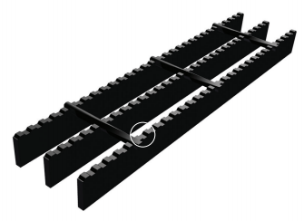
Twisted square cross bar

Weldforged® joints

Approved by:
• Association of American Railroads (AAR).
Produced in two bar spacings
• Box Car
1.583” ctr. - ctr. Bearing Bars • Tank Car
1.643” ctr. - ctr. Bearing Bars
Produced in two bar thicknesses
• 1/8” thick
• 3/16” thick
Weldforged® construction
• for durability
Carbon Steel
• for strength
Serrated top surface
• for slip resistance

Riveted Grating

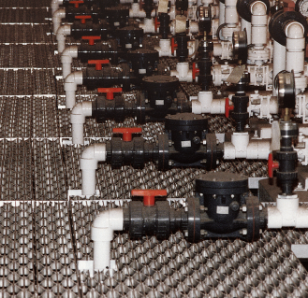

Weights lb./sf.
Bar  Size | Bearing Bar  Dimensions  (inches) | STEEL |  |  |  |  | ALUMINUM
 |  | K | J | U | UJ | W | K | J | U | UJ | W
1 | 3/4” x 1/8” | 6.5 | 9.0 | 7.0 | 7.9 | 4.9 | 2.3 | 3.3 | 2.4 | 2.7 | 1.7
2 | 3/4” x 3/16 | 8.0 | 10.4 | 8.5 | 9.7 | 5.9 | 2.8 | 3.8 | 2.9 | 3.3 | 2.0
3 | 1” x 3/8” | 7.5 | 10.5 | 8.0 | 11.1 | 5.7 | 2.7 | 3.8 | 2.7 | 3.8 | 2.0
4 | 1” x 3/16” | 9.0 | 12.5 | 9.5 | 13.2 | 7.0 | 3.3 | 4.5 | 3.2 | 4.5 | 2.4
5 | 1-1/4” x 1/8” | 8.5 | 12.0 | 9.0 | 12.6 | 6.5 | 3.1 | 4.3 | 3.1 | 4.3 | 2.3
6 | 1-1/4” x 3/16” | 10.5 | 14.7 | 11.0 | 15.3 | 8.1 | 3.8 | 5.3 | 3.8 | 5.2 | 2.8
7 | 1-1/2” x 1/8” | 9.5 | 13.5 | 10.0 | 14.2 | 7.3 | 3.5 | 4.9 | 3.4 | 4.9 | 2.5
8 | 1-1/2” x 3/16” | 12.0 | 16.8 | 12.5 | 17.4 | 9.2 | 4.4 | 6.0 | 4.3 | 6.0 | 3.2
9 | 1-3/4” x 3/16” | 13.5 | 18.8 | 14.0 | 19.4 | 10.4 | 4.9 | 6.8 | 4.8 | 6.7 | 3.6
10 | 2” x 3/16” | 16.0 | 22.9 | 17.0 | 23.3 | 12.3 | 5.8 | 8.0 | 5.8 | 8.0 | 4.2
11 | 2-1/4” x 3/16” | 17.5 | 25.0 | 18.5 | 25.4 | 13.3 | 6.4 | 8.8 | 6.4 | 8.7 | 4.6
12 | 2-1/2” x 3/16” | 19.0 | 27.1 | 20.0 | 27.8 | 14.4 | 7.0 | 9.6 | 7.2 | 9.7 | 5.0


Forging partnershipsTM
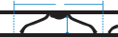
Type

K

J

U

UJ

W
7”

1” CLEAR OPENING
SPAN
t 7”
<>.一
5/8”CLEAR OPENING
SPAN
— 3- 1/2 ”一
w w
!

1” CLEAR OPENING
SPAN

3- 1/2 ”

5/8”CLEAR OPENING
SPAN
< 7”
-/2”CLEAR OPENING
SPAN
Recommended for general applications.

Ornamental design with close bar
centers. Excellent for pedestrian traffic.

Ornamental design
with closer bar centers. Easy under foot.

Combines the closer bar and rivet centers of the U and J.

Economical type
for special industrial uses where wider
opening can be used.
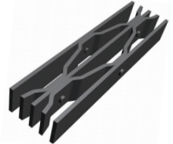
Surfaces:
Available in:
• Carbon Steel
• Stainless Steel (304L & 316L)
• Aluminum
• Plain
• Serrated

Finishes:
• Mill
• Galvanized
• GrateCoat®

Please call for load information and panel sizes.

Surfaces and

Finishes


Forging partnershiSTM

SURFACES

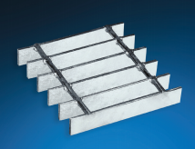
Plain (smooth)
Top surface is available for all products: steel, stain- less steel and aluminum grating products.

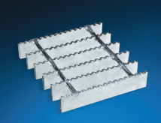
Serrated (slip resistant)
Top surface for all products, except Aluminum I-Bar, Flush Top, and Safe T Grid® . Serrated offers more secure footing, where oil, water or chemicals are present.

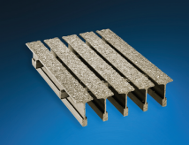
MEBAC® (Metal Bonded Anti-Slip Coatings)
MEBAC products are manufactured using abrasive grit particles encapsulated in metal spray arc that is bonded to an aluminum or steel substrate. MEBAC offers a consistently high coefficient of friction under a wide range of conditions, even when wet with lubricants such as brake fluid and oil, providing margins of safety that are unmatched in the industry. Visit: www.MEBAC.com

FINISHES

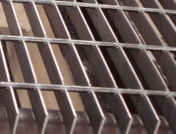
Mill. For carbon steel grating, refers to the natural finish of carbon steel as it comes from the mill. Mill Finish is our standard stainless steel and aluminum grating finish. The welded stainless steel grating and the aluminum grating undergoes caustic cleaning after fabrication which causes discoloration of the finished product.

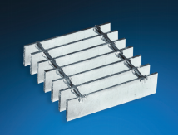
Galvanized. A galvanized steel finish is the best protection for corrosion resistance for steel grating because the zinc metallurgically bonds with to the steel, creating a series of highly corrosion-resistant zinc-iron alloy layers. IKG’s galvanized steel is galva- nized per ASTM A-123 industry standard.

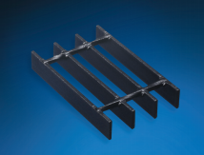
GrateCoat® . IKG offers the highest quality standard paint finish in the Industry. GrateCoat® powder coat finish.

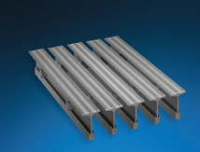
• Standard Steel of 1/8 ” and 3/16 ” conforms to ASTM A1011 CS type B.
• Wire Cross Rods for Welded Grating conform to ASTM A510.
• Steel Bars of 1/4 ” and heavier conforms to ASTM A36.
• Aluminum bars and extrusions conform to ASTM B221 alloy 6063-T6 for bearing bars and 6060-T1 for cross bars.
• Stainless Steel material conforms to ASTM A167 type 304L or type 316L.
Anodized. Oxide coatings of different colors and hard, wear-resisting surface finishes can be applied in aluminum grating.

MATERIALS

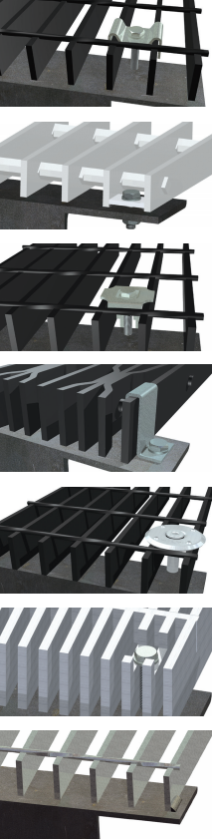

Fastening Methods


Forging partnershipsTM

SADDLE CLIP:

A special bent-clip type bar grating fastener for removable bar grating panels available in aluminum, stainless steel, and galvanized steel. Cross bars may need to be snipped in the field to facilitate placement of saddle clips.

PLATE FASTENERS (aka LUGS/ANCHOR BLOCKS)

Plate fasteners of 1⁄4” or 3⁄16” thick aluminum or steel may be shop welded by the grating manufacturer and used to fasten permanent or removable grating panels. Plate fasteners are recessed thus offering a trip-free surface.

G-CLIP:

Available in aluminum, stainless steel, and galvanized steel used in conjunction with bar grating and embedded grating frames. Cross bars may need to be snipped in the field to facilitate placement of bar grating clamps.

Z CLIP:

Especially helpful in holding down riveted grating. Z Clips are manufactured from stainless steel and are available in 1” (1” and 1-1/4” grating) 1-1/2” (1-1/2” and 1-3/4” grating) and 2” (2”, 2-1/4” and 2-1/2” grating) with a pre-punched hole to accept a 1/4” bolt or TEK screw (by others).

HILTI DISK:

For a wide range of grating fastening applications like: oil and gas installations, offshore and ship building, industrial construction, steel industry, other public facilities, among others.

COUNTERSUNK LAND:

For close-mesh aluminum grating (7/16” bearing bar centers) a countersunk land may be drilled by the grating manufacturer for use with a 1/4” diameter TEK screw (by others).

WELD INSTALLATION:
Tack weld the third bearing bar from each panel side to the support member with 3/16” fillet welds x 3/4” long, plus weld in center of panel at intermediate supports when appropriate.



Engineering Data
Forging partnershiSTM
GLOSSARY OF TERMS
INSTALLATION CLEARANCE

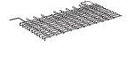
SPAN
CRS. OF
SUPPORTS
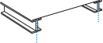

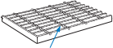

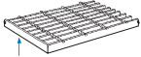

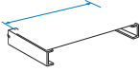
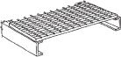
LENG
(SPAN)
TH

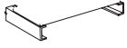
WIDTH
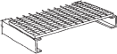

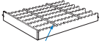
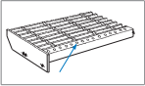

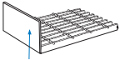

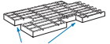

BEARING BAR (Load Bar)
Uniform Load carrying bar spanning across supporting members.
CROSS BAR (Twisted)
Uniform rod, in square twisted steel, forged into and at right angles to the load bar.
BANDING BAR (Edge Bar)
Trim bar, generally as same size as load bars, welded to ends of load bars across panel ends and around notches and penetrations (if any).
LENGTH OF PANEL (Span)
Overall dimension of a panel measured parallel with load bars. (Indicated by symbol)
WIDTH OF PANEL
Overall dimension of a panel measured at right angles to the load bars. (Always called “width” even if greater than the length.)
SERRATIONS
Small notches made in the top edge of the load bar to assist in skid resistance.
NOSING
A member attached to or on the leading edge of a stair tread to assist in skid resistance.
KICK PLATE (Toe Plate)
Heavy section flat bar welded to ends or sides of panels and around cut-outs, etc., when specified. Top edge to be 4” above grating generally.
CUT OUTS
Grating areas removed from panel to permit passage or installation of pipes, equipment, structural and handrail items.

1/4 ”

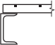

1/4 ”



Panel Span Panel Span
Nominal
Panel Width Panel Width

3/8 ” |  |  |  |  |  | Nominal

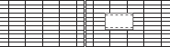
1/4 ”
Actual Cutout will be to nearest load bar
〈 Nominal
3/8 ”


Load Bar (typical)

1/4 ”



 | 1/4 ”



1/2 ”

Min. clearance equal to embed angle thickness

NOTE
Clearance can vary relative to embed angle straightness.



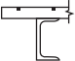

Manufacturing Facilities
Division Headquarters
1514 South Sheldon Road Houston, TX 77015
P. O. Box 310
Channelview, TX 77530 Phone: (281) 452-6637 Fax: (281) 457-6054
Garrett, IN.
1801 Forrest Park Drive Garrett, IN 46738
Phone: (260) 357-6900
Fax: (260) 357-0027

Leeds, Al.
8500 Dunnavant Road Leeds, AL 35094
Phone: (205) 699-2111
Fax: (205) 699-8388

Reno, NV.
6645 Echo Ave Suite C Reno, NV 89506
Phone: (713) 378-3935
Sand Springs, OK.
920 East Pecan
Sand Springs, OK 74063 Phone: (918) 246-0772
Fax: (918) 246-0783
Querétaro, México.
Rejillas Irving
Prol. Corregidora Nte. 487 Col. Parques Industriales Querétaro, Qro. 76160
Phone: 52 (442) 227-1000
Fax: 52 (442) 227-1001

www.IKG.com
Call us at (800) 324-8417


IKG
Forging partnershiSTM

NAAMM
National Association of
Architectural Metal Manufacturers
MEMBER

© 2020 IKG USA, LLCAll rights reserved. 03-2020 (250)





